Group Members:
Christie Chong (cchong@mit.edu), 15.8731
Catherine DiGennaro (cdigenna@mit.edu), 15.873
Aaliya Hussain (ahsn@mit.edu), 15.8731

B
The mean absolute error between the modeled inflation predictions and the actual panel inflation predictions is 1.1105% per year (the corresponding payoff is -1.1105), meaning that on average, the simulated inflation predictions differed from the actual inflation predictions by 1.1105% per average. Given that observed inflation values in the modern era average around 1% per year to 10% per year, the mean absolute error of 1.1105% indicates substantial inaccuracies in the simulated predictions.

The simulated inflation predictions generally follow the trends in the actual inflation predictions (see Figure 1) without any consistent time delays. However, there are significant gaps between the two at nearly all periods, particularly between the periods from 1945 to 1960 and from 1975 to 1985.

Figure 1. Simulated inflation predictions vs. actual panel inflation predictions
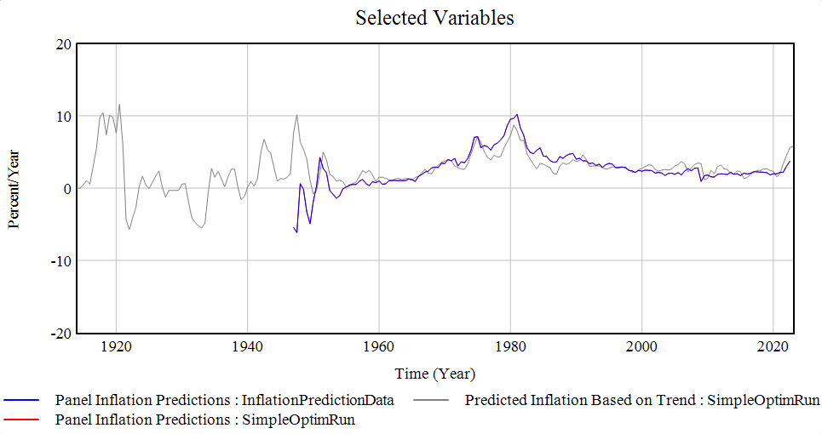

Table 1. Optimized parameter values
Parameter | Optimization Range | Optimized Value
Trend | [0.1, 5] | 5
Time to Perceive Data | [0.1, 1] | 1
Anchor Time | [1, 70] | 52.7393
Weight on Anchor | [0, 1] | 0.529682

C
The major adjustment from the model in B to this model was to split the treatment of the anchor based upon the sign of the trend. The rationale behind this change in the architecture is that positive and negative trends in inflation are perceived differently due to the different socioeconomic implications and drivers of increases versus decreases in inflation, and the difference in perceptions may affect how heavily experts weigh the perceived long-term patterns in inflation (i.e., the weight on anchor) and update their perceptions of the long-term patterns in inflation (i.e., the anchor time) when making forecasts.

Changes to the Model:
The Weight on Anchor and Anchor Time were each “split” into two constant parameters:
- Weight on Anchor if Inflation Positive
- Weight on Anchor if Inflation Negative
- Anchor Time if Inflation Positive
- Anchor Time if Inflation Negative

The table lists the new formulations for other variables that were altered or added to the model:
Variable Name | Description | Units | Formulation
Predicted Inflation Based on Trend | Prediction of inflation based on prior anchor and predictions based on inflation trends, mediated by how much weight is placed on the anchor versus the observed trends. | Percent/Year | Switch if Inflation Positive*(Inflation Anchor * Weight on Anchor if Inflation Positive  + (1-Weight on Anchor if Inflation Positive) * Forward Looking Prediction)  + (1-Switch if Inflation Positive)*(Inflation Anchor * Weight on Anchor if Inflation Negative  + (1-Weight on Anchor if Inflation Negative) * Forward Looking Prediction)
Switch if Inflation Positive | Takes the value of 1 if inflation is positive and 0 if it is negative. | Dmnl | if then else(Inflation Trend>0, 1, 0)
Inflation Information Updating Rate | Rate at which inflation information is updated based on the real inflation rate. | Percent/(Year*Year) | Switch if Inflation Positive*((Inflation Data-Inflation Anchor)/Anchor Time if Inflation Positive  ) + (1-Switch if Inflation Positive)*((Inflation Data-Inflation Anchor)/Anchor Time if Inflation Negative)

Results:
The best mean absolute error achieved is 0.854188% per year (the corresponding payoff is -0.854188), which represents an approximate 20% reduction in error from the original value of 1.1105% per year (payoff of 1.1105) from the model in B. As expected from the reduction in the mean absolute error, compared to the simulated inflation predictions from the model in B, the new simulated inflation predictions better match the actual inflation predictions, in terms of the gap between the values (see Figure 2). The improvement in the fit appears to be evenly distributed among all periods (i.e., it is not particularly pronounced in any particular periods).

Figure 2. Simulated inflation predictions vs. actual inflation predictions - Sign-dependent anchor
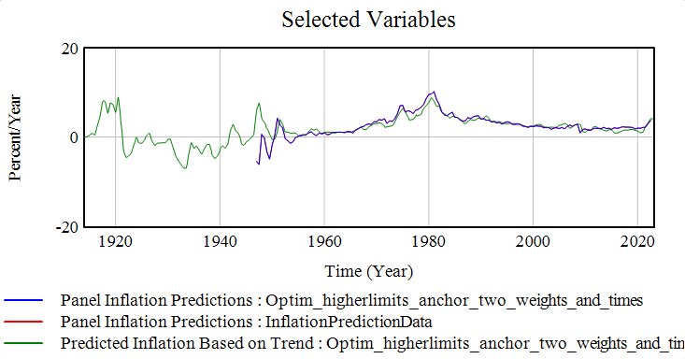

The table below shows the optimized values for the constant parameters:
Parameter Name | Units | Optimization Range | Optimized Value
Trend Horizon | Year | [0.1, 10] | 0.1
Time to Perceive Data | Year | [0.1, 10] | 3.01799
Weight on Anchor if Inflation Positive | Dmnl | [0, 1] | 0.677084
Weight on Anchor if Inflation Negative | Dmnl | [0, 1] | 0.770415
Anchor Time if Inflation Positive | Year | [1, 70] | 38.4553
Anchor Time if Inflation Negative | Year | [1, 70] | 3.05794

The optimization results demonstrate that the experts both place moderately more weight on the anchor and update the anchor significantly faster (by an order of magnitude) when the inflation trend is negative versus when the trend is positive. Explanations for this disparity may include greater optimism when faced with negative inflation trends (as rising inflation is typically perceived more negatively) or a perception that negative inflation trends signal more drastic changes to the underlying economic situation (as inflation reduction is often the result of major economic/fiscal policy changes or of economic recessions as opposed to normal economic growth). These explanations require further experimental validation.

D
The following elements were included in the predicted inflation values from our model:
- Inflation reference values:
  - Inflation Anchor - The inflation anchor from B (i.e., the simple anchor with a single anchor weight and anchor time) was included to serve as an indicator of the long-term trends in inflation over time.
  - Average Inflation over Lookback Period - An average inflation rate over an optimized lookback period was included to serve as a short-term reference value for the inflation value. An average was used in place of the exponential smoothing from the models in B and C on the assumption that the exponential smoothing process was an artifact of human trend perception rather than part of optimal forecasting.
- Fluctuations in inflation:
  - Change in Inflation - The change in inflation captured the immediate fluctuation in the most recent inflation value from the short-term average and served as an indicator of the magnitude of the short-term volatility in the inflation.
  - Switch for Turnaround - Based on the assumption that trends in inflation “turn around” (i.e., switch signs) during periods of high variability in trends, the model simplistically predicted a trend turnaround if the recent noise (i.e., standard deviation in inflation over an optimized lookback period) was greater than an optimized threshold. If the trend was predicted to turn around, the predicted change in inflation was assumed to flip signs relative to the previous value.
- Learning from error:
  - Proportion of Mean Error to Adjust - The model accounted for its past errors by incorporating an optimized proportion of the mean error into its values in order to correct any long-term biases that it may have in making predictions.
The predictions were calculated as a weighted average of the anchor, which captured the long-term variation in inflation, and the short-term average inflation adjusted by fluctuations in inflation and learnings from error, which captured the short-term fluctuations in the inflation. The basic assumption behind the two-part weighted average is that variation in inflation can be partitioned into long- and short-term variation, both of which needs to be accounted for.

The following parameters were added to the model:
- Lookback Time
- Noise Lookback Time
- Proportion of Previous Error to Adjust
- Turnaround Threshold

The table lists the new formulations for major variables that were altered or added to the model:
Variable Name | Description | Units | Formulations
Average Inflation over Lookback Time | The average value of inflation over the time period denoted by the lookback time. | Percent/Year | GET DATA MEAN(Inflation Data , Time - Lookback Time , Time )
Change in Inflation | Most recent trend in inflation compared to the average inflation over the estimated lookback time. | Percent/Year | if then else(Time<First Inflation Data Point :OR: Time>End Time, 0, Inflation Data  -Average Inflation over Lookback Time)
Forward Looking Prediction | Prediction of inflation over the next year based on the past data and the current perceived inflation trend, adjusted for the past prediction error. | Percent/Year | Switch for Turnaround*Change in Inflation * -1 + (Average Inflation over Lookback Time  + Mean Absolute Error in MatchingRIPD*Proportion of Previous Error to Adjust  )  +  (1-Switch for Turnaround) + Average Inflation over Lookback Time + Mean Absolute Error in MatchingRIPD  *Proportion of Previous Error to Adjust
Recent Noise in Inflation | Standard deviation in inflation data over the noise lookback period. | Percent/Year | if then else(Time<First Inflation Data Point :OR: Time>End Time, 0, GET DATA STDV  (Inflation Data, Time - Noise Lookback Time , Time ))
Switch for Turnaround | Takes the value of 1 if inflation is above the turnaround  threshold and 0 otherwise. | Dmnl | if then else(Recent Noise in Inflation>Turnaround Threshold, 1, 0)

Results:
The payoff that our model achieved was -1.74, which does not indicate a particularly high degree of accuracy. Additionally, relative to both the actual inflation and the predicted inflation from the panel, our model demonstrated a time delay in forecasting trends (see Figure 3). Both the inaccuracy of our model and the time lag in predicting inflation are likely due to a lack of other econometric data that would provide more accurate and reliable signals of changes in inflation.

Figure 3. Predicted inflation predictions vs. panel inflation predictions vs. actual inflation
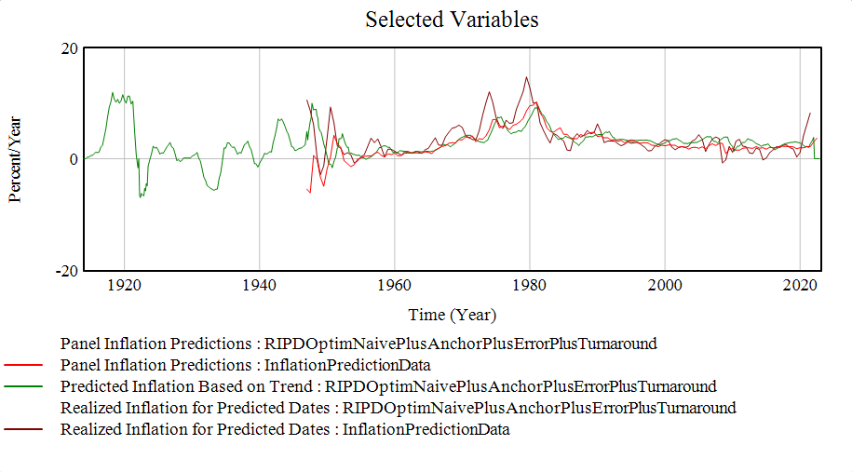

The table below shows the optimized values for the constant parameters:
Parameter Name | Units | Optimization Range | Optimized Value
Lookback Time | Year | [1, 30] | 1.16206
Weight on Anchor | Dmnl | [0, 1] | 0.703113
Anchor Time | Year | [1, 70] | 70
Proportion of Previous Error to Adjust | Dmnl | [-1,1] | -0.459116
Noise Lookback Time | Year | [1, 30] | 4.0184
Turnaround Threshold | Percent/Year | [0,20] | 12.1725
The most notable result from the optimization process is that the optimal anchor time is quite long, which could be the result of our attempt to partition variance into long- and short-term measures.

